The internal datastructure
(part of the data dictionary)
Version 0.0.218-11-2013
Jan Welvaarts

Version management

Content

Table of Contents
Version management 2
Content 3
1Preface 4
2Principles 5
3Information per variable category 6
3.1List of passed BG's 6
3.2Movement authority (MA) 7
3.3Speed profile 10
3.4Gradients 10
3.5List of announced BG's 10
3.6Anounced transitions 10
3.7Train position 10
3.8Train characteristics 10
3.9DMI parameters 10
3.10Brake system model 10
3.11DMI mirror 10
3.12Procedure status 10
3.13List of BG (SR and SH) 10
3.14Mode and level status 10
3.15RBC contact status 10
3.16STM status 10
4Data structures 12
4.1List of passed BG's 12
4.2Movement authority 16
5Variables 19

Preface
This document defines the rough structure of the internal openETCS data structure. Purposes:
- Structure the data to keep it manageable
- Create a common understanding of the structure
- Synchronize the structure for variables defined for different functions (by different groups)

Many variables contain different information, but shall be structured in the same way. The most obvious example is location based information. Locations are necessary for many data structures and shall therefore be stored in the same way. This is not guaranteed if different are defining variables independent from each other. Therefore This document will define a top level structure for the date dictionary and set requirements for more detailed variables. The structure of the internal data will be targeting the use of the data (i.e. it will not be a copy of the source).

Roughly three types of internal data are distinguished:
- Location based information describing the infrastructure.
- Description of the train (including train position).
- Status information: mode, level, dmi status etc.

The “variable categories” shown in figure 1. Variable types to be used to describe the information listed shall be decomposed down to the level of standard data types (boolean, word, integer, double,....).
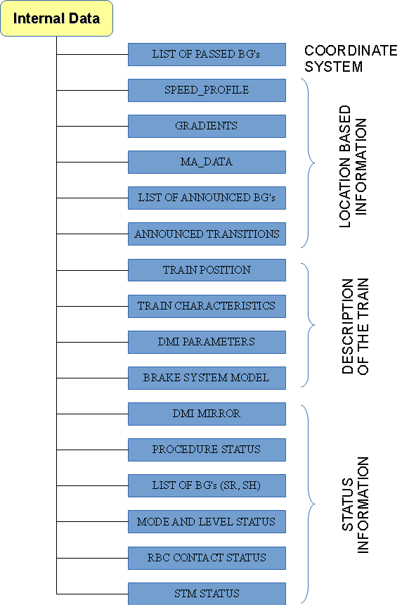
The first chapter defines a number of requirements the internal data structure has to fulfill (i.e. the requirements).

The second chapter describes for each of the “variable category” which information it globally contains, where the information is coming from and what the use of the information is.

In the third chapter the individual data structures is described, starting with the “coordinate system” as the “list of passed BG's” serves as a basis for all location based information.

In the last part the internal data structure will be detailed using variables defined by the groups which are defining functions.

Figure 1:
High level data structure for the internal data

Principles
In this chapter a number of principles will be set to tune the format of the variables proposed by different groups which are defining functions:

Principle | explanation | ID
The internal data structure shall be targeted on the user of the data not primarily on the source. | The input part of the system shall translate the different formats of information to one standard to simplify the actual functionality of the system.
The data structure shall minimize the reanalysis of data if other data is received. I.e. not shift data, avoid changing data for all stored locations if a new LRBG is detected, etc. | By avoiding peaks in the processor load when BG's are detected and/or messages are received, the system will become more predictable.
All data in the data structure shall be accessible without searching, i.e. pointer structure shall make searching superfluous. | As all necessary entries are known, this can be realized and will safe (unpredictable) processor time.
All data types shall be based on a limited number of standard data types. (for now): Boolean, word, integer, double, text | Eases the validation
No redundant data shall be stored. | Storing the same information more than once can lead to mistakes, requires more memory and more attention when updating data.  E.g. the accuracy of locations depends only on the BG which has sent the information plus linking and odometer information. The accuracy shall therefore be stored in the structure describing the BG.
Similar data shall be stored in similar structures. | e.g. a lot of data is location based. This shall not be stored partially incremental and partially from one reference.  All distances in the same, all locations..., all times..., all speeds,.. etc.
Memory is not dynamically allocated. For each type the maximum number of instances shall be determined. This number can be created at start-up | Dynamic allocation of memory increases the number of states and therefore the validation effort.

Information per variable category

List of passed BG's
For several reasons BG's passed may not be forgotten immediately:
- In level 2/3 the RBC might sent location based data in reference to one of the (maximum) eight last BG's which are detected and reported to the RBC.
- Locations shall be stored in reference to the BG which was used as a reference for the message in which the location based information was received because:
- (New) linking information for BG's may be received after the BG's were detected. In that case the distance between the “original reference BG” and the LRBG can change. The distance between the Location and the LRBG will than change, thus the information which BG was the “original reference BG” shall be stored.
- To avoid the necessity of recalculating the distance for every stored location whenever a BG is becoming (new) LRBG, the link to the “original reference BG” shall be kept.
- As the inaccuracy for all locations with the same “original reference BG” is equal, this inaccuracy can be stored with the information concerning the BG to avoid redundant information. (also valid for unlinked BG's!)
- xxxxxxx

Per passed BG the following information shall be remembered:
- The inaccuracy of the positioning of the BG: LOC_ACC
- A link to the previous linked BG.
- The linking distance from the “previous linked BG in the chain”.
- A link to the previous unlinked BG.
- The measured absolute position (an absolute position from the odometer of the distance travelled since start up) at which the BG was detected.
- The measured distance from the previous BG.
- The maximum overestimation of the measured distance from the previous BG.
- The maximum underestimation of the measured distance from the previous BG.
- The announced passing directional
- The linking reaction
- Information if the BG is linked and can thus be used in communication to the RBC.
- Information if the BG is a “repositioning BG” for which the linking distance is not exact.
- Distance to the furthest location given by the BG: to determine if all locations given by the BG are passed, thus the BG can be deleted? (unless there are less than 8 linked BG's in memory)
The above information shall enable the system to:
- Calculate the distance from the BG to the LRBG including inaccuracies (in case not all linking information is available), based on odometer information and/or on linking information.
This shall be done at every detection of a new (LR)BG
- Determine if the “BG information” may be deleted from memory.
- Store a new BG (when detected) without shifting data. To avoid shifting stored data a circular buffer is proposed.
- Give the inaccuracy for each location.

Movement authority (MA)
For speed and distance supervision the allowed distance to run shall be clear. This information is given, on request of the on board unit, in pieces which can all have their specific time out values. The parameters defining when an MA shall be requested by the OBU, and the structure to store the MA are part of the internal data structure.

The data structure storing the MA-request parameters shall be able to contain the following information:
- Time repeating the MA request, i.e. an MA shall be requested if the time elapsed since the last MA request reaches this value.
- Time, before reaching the indication point, at which an MA request shall be sent.
- Time, before any MA-timer elapses, at which an MA request shall be sent

The data structure storing the MA shall be able to contain the following information:
- A number of sections with their starting location (i.r.t. the LRBG), a timer stop location and a timer.
- End section information: the length of the end section including the length, an end section timer start location and an end section timer.
- A limit of authority speed plus timer related to this speed (LOA timer)
- A danger point including the related release speed.
- An overlap including overlap timer a start location for the overlap timer and a with the overlap related release speed.

The above data structure shall enable the following functions:
- xxxxxxxxxx

A graphical representation of the “MA-structure” is given at the next pages:
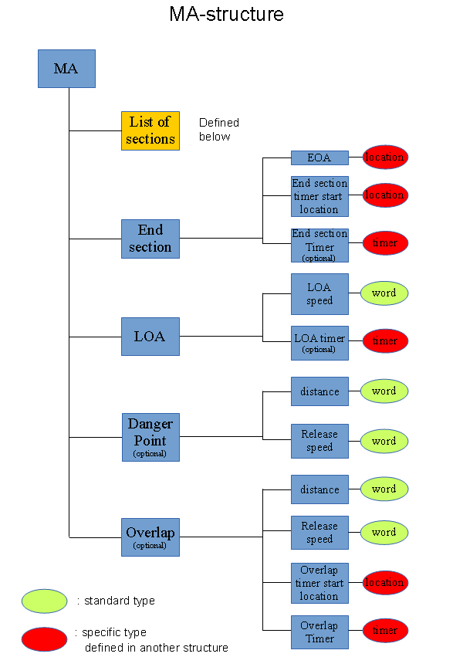
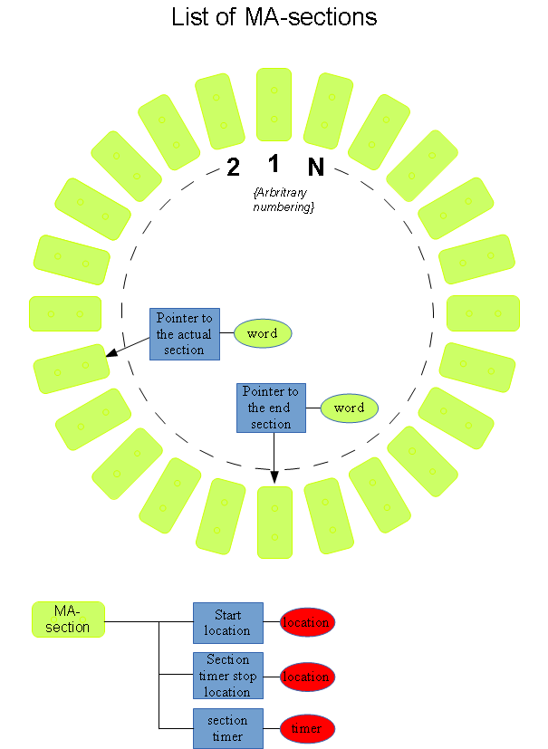

Speed profile

Gradients

List of announced BG's

Anounced transitions

Train position

Train characteristics

DMI parameters

Brake system model

DMI mirror

Procedure status

List of BG (SR and SH)

Mode and level status

RBC contact status

STM status

xxxxxxxx

Data structures

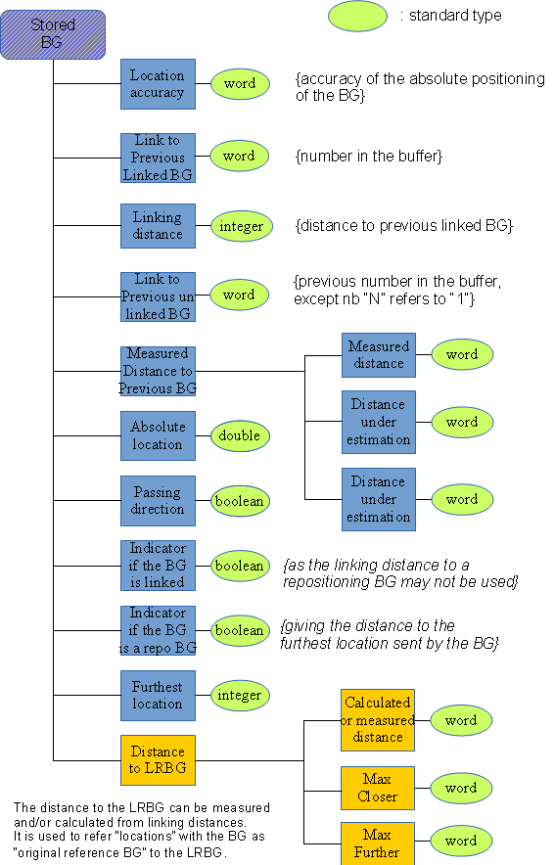
List of passed BG's

The structure for storing BG's shall allow the storage of information needed to calculate the distance between the BG and the LRBG. This is realized by storing the distance to the previous linked BG and the measured distance to the previous BG (which may also be an unlinked BG).

Storing the data structures as shown in figure xxxx (left) in a circular buffer enables calculating the least restrictive linking distance (using linking or odometer information). The circular buffer is shown in figure xxxx (next page). Locations shall refer to their “original reference BG”, see figure xxx.

The maximum number of stored BG is to be determined.

Figure xxxx
Data structure for storing information concerning an already detected BG

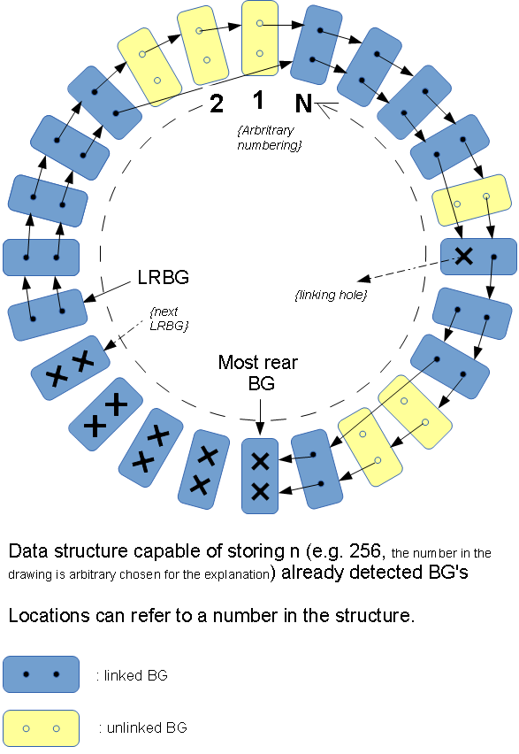
Figure xxxx
Circular buffer for storing BG-information

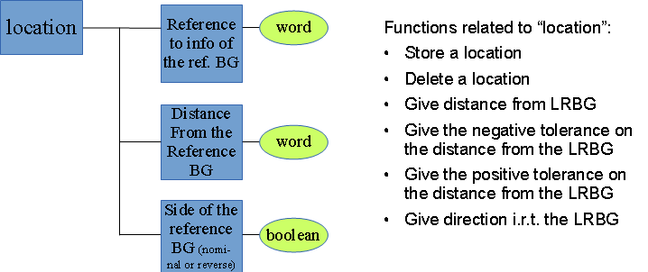
Figureyyy Data structure for storing a “Location”

Movement authority
A movement authority is build with sections which have individual time-outs. Per section, for the end section, for the LOA and for the overlap timers have to be started. Therefore a specific timer type is defined:

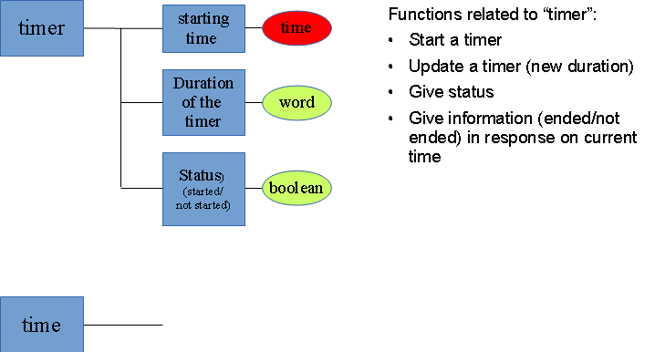
Figure xxxx: TIMER
A timer can be:
- started
- updated (set a new duration)
- ended (time-”starting time” > duration)
- removed

Below the data structure for a complete MA is shown:

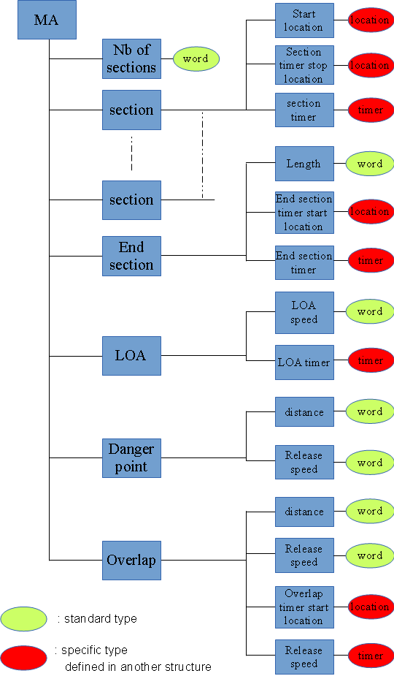

Variables

Example for the MA (names to be defined):

